Weekly Construction Progress Report – Week 25
Harrow Bay Offshore Wind · 15 Jun – 21 Jun 2026
Elena Márquez · 22 June 2026 · HB-PM-RPT-2026-W25

1. Summary
No monopile was installed this week; the total remains 9 of 40. The foundation campaign is 2 piles behind the Rev 2 baseline (11 planned). Waiting on weather amounted to 16 hours.
Area | Status | Comment
Overall schedule | Amber | 9/40 monopiles vs. 11 planned
Foundations | Amber | TPs installed: 8
Offshore substation | Green | Fabrication / load-out
Cables | Green | Manufacturing on schedule
HSE | Green | No incidents

2. Progress
Metric | This week | Cumulative | Plan (cum.) | Variance
Monopiles installed | 0 | 9 | 11 | -2
Transition pieces installed | 0 | 8 | – | –
Waiting on weather (h) | 16 | 199 | – | –
Persons on board (avg.) | 93 | – | – | –
Man-hours MV Sea Atlas | 7,708 | 89,806 | – | –
Lost time injuries | 0 | 0 | 0 | 0
Recordable injuries | 0 | 0 | – | –
Near misses reported | 0 | 3 | – | –
HSE observation cards | 20 | – | – | –

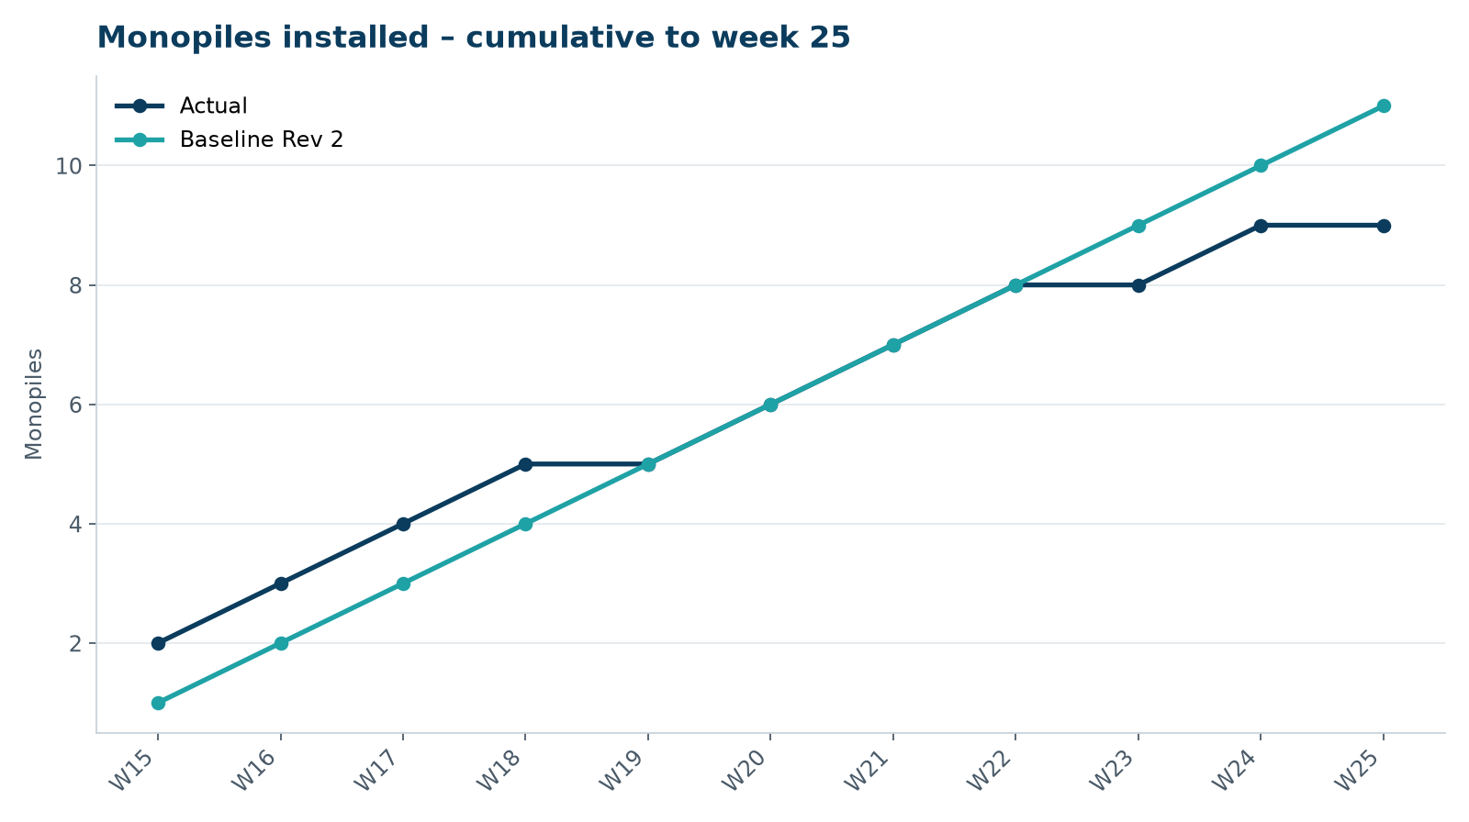
Figure 1 – Monopile installation progress, W15 to W25

3. Key activities this week
- No monopile installed: MV Sea Atlas in port 16–19 June for load-out of monopiles HB-A10 to HB-A12.
- OSS jacket sailed away on 19 June on a transport barge.
- 16 hours waiting on weather.

4. Health and safety
No lost time injuries. 20 observation cards submitted; top theme: mooring line handling.

5. Environment
- No piling this week; passive acoustic monitoring stations HB-PAM-01 to -04 operational.

6. Issues and risks
- HB-RISK-001 weather: 16 h downtime this week.

7. Look-ahead next week
Install HB-A10 before the seasonal restriction; OSS jacket installation.
Prepared by Project Controls (Gareth Lewis); approved by Elena Márquez. Distribution: project team, Steering Committee, Halden Turbine Systems, Lenders' Technical Adviser.

